SIMATS ENGINEERING (SAVEETHA SCHOOL OF ENGINEERING)
Department of Computer Science and Engineering
CO2 Assessment Tool 2 — Architecture Design Assignment
ARCHITECTURE DESIGN REPORT
SkillSphere
AI-Driven Career Readiness and Personalized Learning Recommendation Platform
Course Code | CSA10 / CSA1063
Course Title | Software Engineering
CO Assessed | CO2 — Requirements Analysis, Scalable Architecture Design, Feature Prioritization
Student Name | B Lakshmi narasimhudu
Registration Number | 192525460
Date | 6-7-2026
Duration | 60 minutes
Code of Conduct
I __B Lakshmi narasimhudu (192525460)____________________________ (Name / Reg. No.) certify that this submission is my original work and that I have adhered to the guidelines specified for this assessment. I understand that any violation of academic integrity rules will result in disciplinary action.
Signature of the Student: _B Lakshmi narasimhudu___________________________

1. System Requirements Analysis

1.1 Problem Overview and System Objectives
SkillSphere is an AI-driven career readiness and personalized learning recommendation platform intended to close the gap between academic learning and industry expectations. The system continuously analyzes a learner's academic records, technical skills, certifications, project work, coding profiles, aptitude scores, and career interests, then combines this profile with real-time labour-market and course-provider data to identify skill gaps, predict suitable career paths, and recommend targeted learning resources.
The primary objectives that drive the architecture are: (a) provide accurate, explainable, and continuously updated career and skill-gap recommendations; (b) support thousands of concurrent students, faculty, and institutional users across web and mobile channels; (c) integrate reliably with a growing number of third-party learning, coding, and job-market platforms; and (d) maintain data privacy and academic-record security while remaining flexible enough to accommodate new ML models and data sources over time.

1.2 Functional Requirements
- Student registration, authentication, and profile management (academic records, certifications, coding profiles, resumes).
- Skill-gap analysis comparing a learner's competency profile against role-specific industry requirements.
- Personalized learning-path and career recommendation generation using Machine Learning models.
- Career-path prediction and classification (e.g., AI Engineer, Data Scientist, Full-Stack Developer).
- Integration with external platforms — LinkedIn, GitHub, LeetCode, HackerRank, Coursera, Udemy, NPTEL, edX, and job portals — to enrich learner and market data.
- Interactive dashboards for students (progress, readiness score) and for faculty/institutions (cohort analytics, placement readiness).
- Notification and alerting for new recommendations, deadlines, and skill-gap updates.
- Periodic retraining of recommendation and prediction models as new learner and market data arrive.

1.3 Non-Functional Requirements
- Scalability — the platform must scale horizontally as the number of institutions, students, and third-party data feeds grows.
- Performance — recommendation and dashboard queries should return within a few seconds even under concurrent institutional load.
- Reliability & Availability — career guidance is used for time-sensitive decisions, so the platform should target high uptime with graceful degradation if an ML or external service is temporarily unavailable.
- Security & Privacy — academic records, certifications, and personal data require encryption, role-based access control, and compliance with data-protection norms.
- Maintainability & Extensibility — new ML models, data sources, and institutional customizations must be addable with minimal disruption to existing services.
- Interoperability — the system must consume heterogeneous external APIs (job portals, learning platforms, coding platforms) with differing formats and rate limits.

1.4 Key Quality Attributes Influencing the Architecture
Because SkillSphere blends transactional functionality (profiles, dashboards) with computationally intensive AI/ML workloads (recommendation generation, career prediction) and continuous third-party integration, the architecture must simultaneously support scalability, maintainability, reliability, availability, performance, and security as first-class concerns rather than after-thoughts. This combination — independently scalable AI components, frequent external integration, and sensitive student data — is the central factor that shapes the architectural style selected in Section 2.

2. Selected Software Architecture

2.1 Architectural Style: Hybrid Layered + Microservices Architecture
SkillSphere adopts a hybrid architecture that combines a Layered (presentation–gateway–service–data) organization at the macro level with a Microservices decomposition of the application/business logic layer. The system is presented to users through a Layered structure (Presentation → API Gateway/Security → Services → Data), while the Service layer itself is implemented as a set of independently deployable microservices — User Profile Service, Skill Assessment Service, Recommendation Engine, Career Prediction Service, and Notification & Dashboard Service — communicating through a message broker and RESTful APIs.

2.2 Justification
Independent scalability of AI workloads: The Recommendation Engine and Career Prediction Service perform CPU/GPU-intensive ML inference and periodic retraining. Isolating them as separate microservices allows them to be scaled, versioned, and deployed independently of lightweight services such as User Profile or Notification, avoiding resource contention and unnecessary scaling of the whole system.
Frequent and heterogeneous external integration: SkillSphere must continuously integrate with LinkedIn, GitHub, Coursera, job portals, and certification providers, each with different schemas, rate limits, and failure modes. A microservices boundary lets integration logic be encapsulated, versioned, and fault-isolated within the relevant service instead of coupling it to the core application.
Layered separation for simplicity and security: A layered organization at the top level (Presentation, Gateway/Security, Application Services, Data) keeps the overall system easy to reason about, enforces a single, centrally-governed entry point (API Gateway with Auth) for all client traffic, and simplifies applying consistent security and rate-limiting policies.
Alignment with the team's operating context: As an academic capstone-scale system, a small team benefits from the layered mental model for day-to-day development, while the microservices boundary is reserved specifically for components that genuinely need independent scaling and release cycles (ML services, integration-heavy services) — rather than fragmenting every feature into a separate service, which would add unnecessary operational overhead.
Alternative styles were considered and rejected as the sole style: a purely monolithic layered system would be simple to build but could not scale the ML workloads independently or isolate third-party integration failures; a pure microservices/SOA design for every feature would introduce excessive operational complexity (service discovery, distributed transactions) disproportionate to the project's scale. The hybrid approach was judged the best balance of simplicity, scalability, and fault isolation for SkillSphere's specific requirements.

3. Software Architecture Diagram
The diagram below illustrates the overall structure of SkillSphere, including the presentation layer, API gateway and security layer, the application/AI microservices, the asynchronous messaging backbone, the data layer, and the external systems it integrates with.
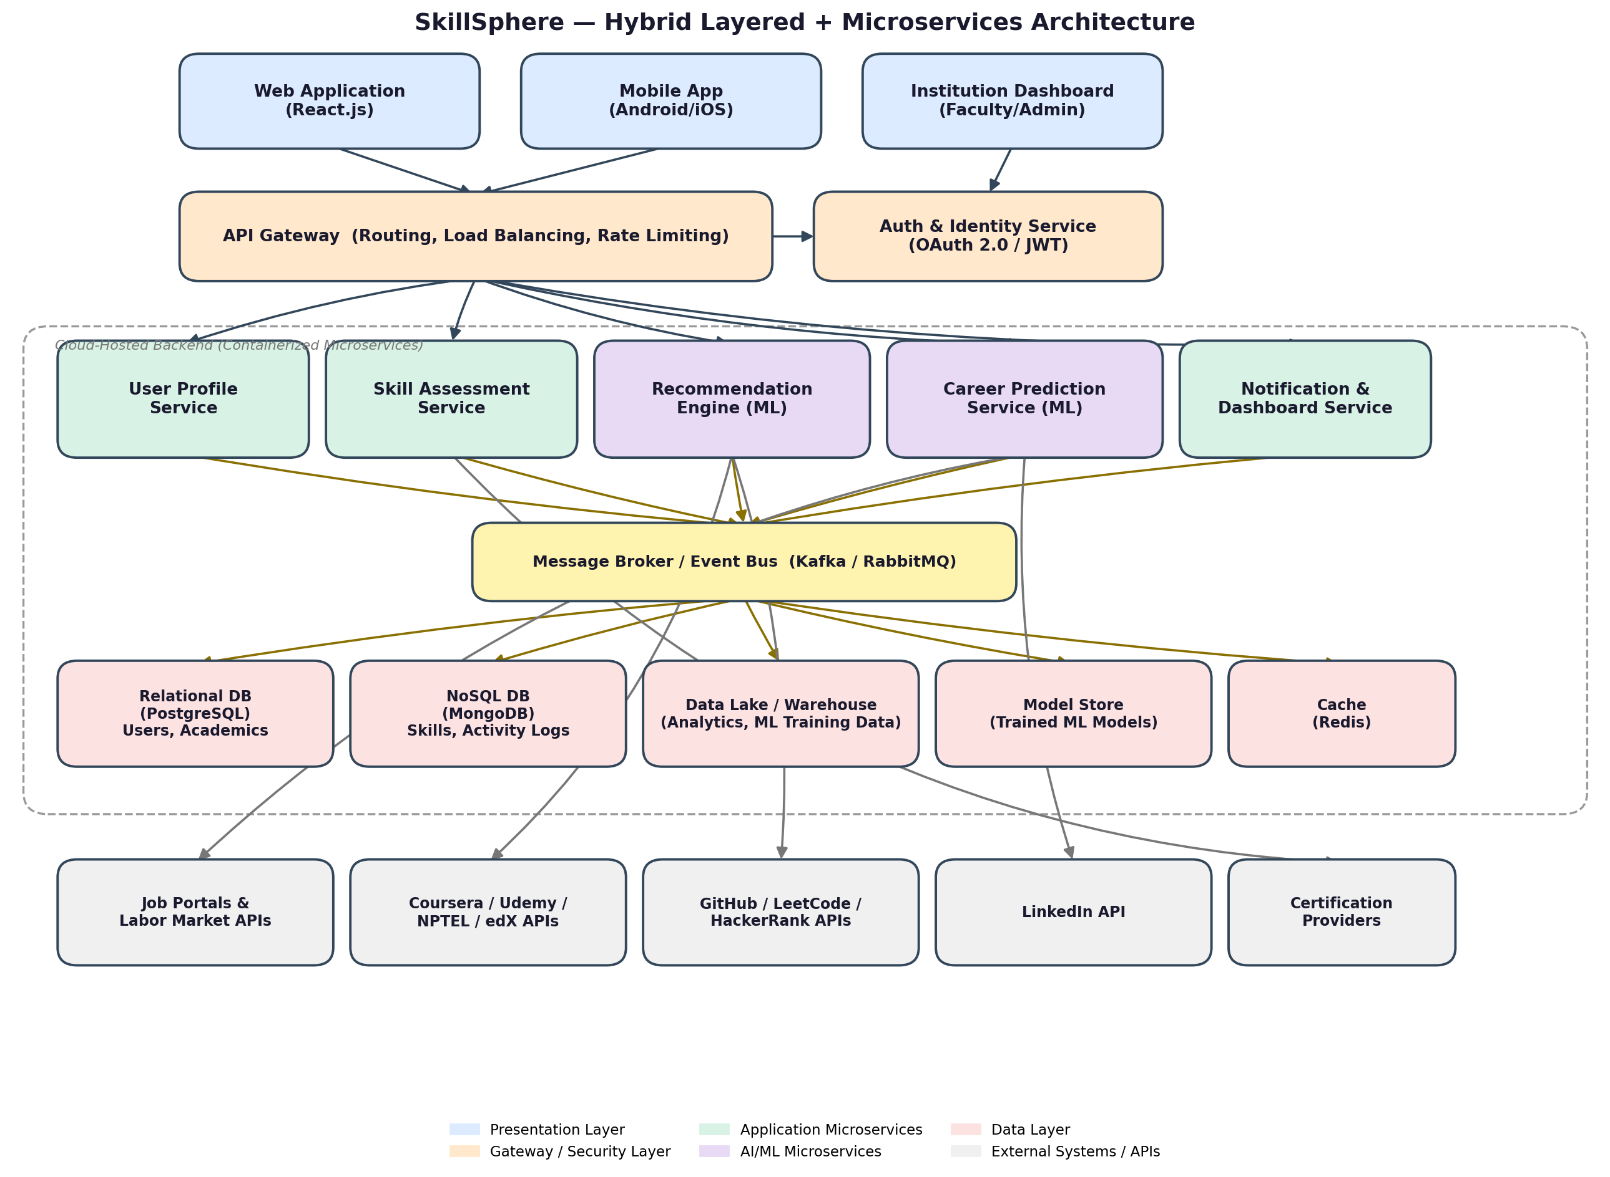
Notation: rounded rectangles represent components/services; arrows indicate the primary direction of a request, event, or data flow; the dashed boundary denotes the cloud-hosted, containerized backend. Solid dark arrows show synchronous request flow (client → gateway → services); amber arrows show asynchronous, event-driven communication through the message broker; grey arrows show outbound calls to external, third-party APIs.

4. Components and Their Interactions

4.1 Component Responsibilities
Component | Responsibility
Web Application / Mobile App | Client interfaces through which students and faculty register, view recommendations, and track progress.
Institution Dashboard | Web interface for faculty/administrators to monitor cohort-level readiness and analytics.
API Gateway | Single entry point for all client requests; handles routing, load balancing, request throttling, and API versioning.
Auth & Identity Service | Authenticates users and issues tokens (OAuth 2.0 / JWT); enforces role-based access control.
User Profile Service | Manages student/faculty profiles, academic records, certifications, and resumes.
Skill Assessment Service | Evaluates learner competencies and computes skill-gap scores against role requirements.
Recommendation Engine (ML) | Generates personalized learning-path and resource recommendations using trained ML models.
Career Prediction Service (ML) | Classifies learners into suitable career roles using predictive ML models.
Notification & Dashboard Service | Pushes alerts/updates to users and aggregates data for interactive dashboards.
Message Broker / Event Bus | Decouples services via asynchronous events (e.g., profile-updated, skill-completed).
Data Layer (SQL, NoSQL, Data Lake, Model Store, Cache) | Persists structured records, unstructured logs, analytics data, trained models, and frequently accessed data.
External Systems | Third-party platforms (LinkedIn, GitHub, Coursera, job portals, certification providers) supplying enrichment data.

4.2 Communication and Workflow
A typical workflow begins when a student updates their profile or completes an activity (e.g., a certification) through the Web or Mobile client. The request passes through the API Gateway, which authenticates the user via the Auth & Identity Service and routes it to the User Profile Service over synchronous REST calls. The User Profile Service persists the change and publishes an event (e.g., "profile-updated") to the Message Broker.
The Skill Assessment Service, Recommendation Engine, and Career Prediction Service subscribe to relevant events on the broker. On receiving an update event, the Skill Assessment Service recomputes the learner's competency profile and publishes a "skills-updated" event; the Recommendation Engine and Career Prediction Service then asynchronously regenerate personalized recommendations and career predictions, drawing on cached labour-market data periodically refreshed from external systems (job portals, LinkedIn, course providers). Results are written back to the data layer and pushed to the Notification & Dashboard Service, which updates the student's dashboard and, where relevant, sends a notification.
This event-driven interaction between microservices — layered beneath a synchronous, gateway-mediated interaction with clients — allows compute-heavy ML recomputation to happen asynchronously without blocking the user-facing request, while still giving clients a simple, consistent synchronous API for day-to-day operations such as login, browsing recommendations, and viewing dashboards.

5. Discussion of Quality Attributes

5.1 Scalability
Each microservice can be containerized and scaled independently based on load. The Recommendation Engine and Career Prediction Service, being computationally heaviest, can be scaled out with additional instances or GPU-backed nodes during peak usage (e.g., placement season) without over-provisioning lighter services such as Notification. The message broker further decouples producers from consumers, allowing services to process events at their own pace.

5.2 Security
All client traffic is funnelled through the API Gateway, which enforces authentication (OAuth 2.0/JWT) and role-based access control before requests reach internal services, reducing the attack surface. Sensitive data — academic records, certifications, personal identifiers — is encrypted at rest in the relational and NoSQL stores and in transit via TLS. Service-to-service communication within the cloud boundary is restricted to the internal network, and external API keys/credentials are managed centrally rather than embedded in individual services.

5.3 Performance
Frequently accessed data (e.g., current recommendations, dashboard summaries) is served from a Redis cache to minimize database round-trips. Synchronous, user-facing operations (login, viewing existing recommendations) are kept lightweight, while expensive ML recomputation is offloaded to asynchronous, event-driven processing so that the client-facing latency remains low even when a full model recomputation is comparatively slow.

5.4 Reliability
Decoupling services through the message broker means that a temporary failure or slowdown in one service (e.g., Career Prediction) does not directly block others (e.g., Notification); events queue and are processed once the service recovers. Retry policies and circuit breakers at the integration points with external systems prevent third-party outages from cascading into the core platform.

5.5 Maintainability
Each microservice owns a clearly bounded responsibility and can be developed, tested, deployed, and versioned independently, which simplifies adding new ML models, new external integrations, or new recommendation logic without touching unrelated services. The layered top-level structure additionally keeps cross-cutting concerns such as authentication and routing centralized rather than duplicated across services.

5.6 Availability
Stateless services behind the API Gateway can be replicated across multiple instances/availability zones, and the asynchronous, event-driven core allows the platform to continue accepting and queuing requests even if a downstream ML service is briefly unavailable, with degraded (e.g., "recommendations updating") rather than failed responses to the user.

6. Justification of Architectural Decisions

6.1 Rationale
The decision to combine a layered top-level structure with a microservices decomposition of the service tier was driven directly by SkillSphere's dual nature: it is simultaneously a transactional platform (profiles, dashboards, notifications) and an AI-heavy platform (recommendation generation, career prediction) that must integrate with numerous external data sources. Keeping ML-heavy and integration-heavy components as independently deployable services directly addresses the scalability, reliability, and maintainability requirements identified in Section 1, while the layered organization keeps the system approachable for a small development team and centralizes security enforcement.

6.2 Trade-offs Considered
- Monolithic layered architecture: simpler to build and deploy initially, but would force the entire application to scale together and would make isolating ML workload spikes or third-party integration failures difficult — rejected as the primary style but retained conceptually at the top level for simplicity.
- Full microservices/SOA for every feature: offers maximum independent scalability and team autonomy, but introduces significant operational overhead (service discovery, distributed tracing, data consistency across services) that is disproportionate to the current project scale — mitigated by applying microservices selectively, only to components that need it.
- Synchronous-only service communication: would simplify reasoning about data flow, but would tightly couple client-facing latency to expensive ML computation — mitigated by introducing the message broker for asynchronous, event-driven recomputation.

6.3 Support for Future Enhancements and Long-Term Maintainability
The hybrid architecture directly supports the future scope identified for SkillSphere. New capabilities — a Generative AI assistant for career Q&A, additional integrations (Blockchain-verified credentials, more learning platforms), or advanced deep-learning career-prediction models — can be introduced as new microservices or as upgraded versions of the existing ML services, published to the same event bus, without requiring changes to the Presentation or Gateway layers. Similarly, new institutional dashboards or reporting requirements can consume existing events and data-layer stores without modifying the core recommendation pipeline. This separation of concerns gives the platform a clear path for incremental growth while keeping each individual service small enough to remain maintainable.

